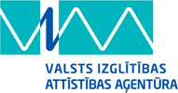 | NORDPLUS projekts  „Studēt vai strādāt?”  („To study or to work?”)  projekta nr.  NPJR-2014/10407 |  | 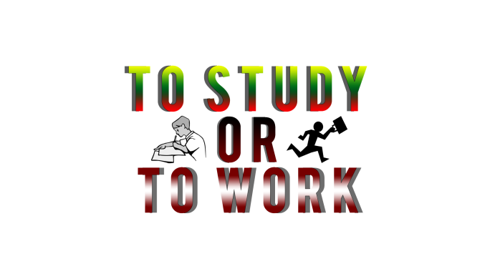

Publications:
Latvia | Lithuania
http://www.4vsk.jelgava.lv/images/skolas_avize/2014_2015/avize_janvaris.pdf  page 11 | https://www.vrsa.lt/index.php?2280621113
http://www.jelgavasvestnesis.lv/page/53?news_id=28751 | https://www.vrsa.lt/index.php?404564506
http://www.izglitiba-kultura.lv/avize/nr7-473 | http://www.vrsa.lt/index.php?174790979

